**DBMS Lab 7**

**UNION, INTERSECTION, MINUS operators**

**GAURAV MAHAJAN PES1UG20CS150 SECTION C**

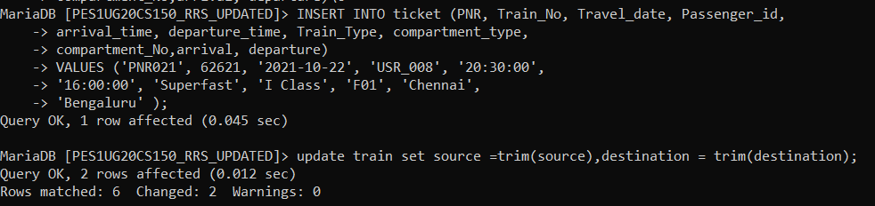

1. Find the list of passengers (user_id, user_type First name and

last name) who have traveled from Bengaluru to Chennai during

the month of Oct 2021 and Aug 2022.

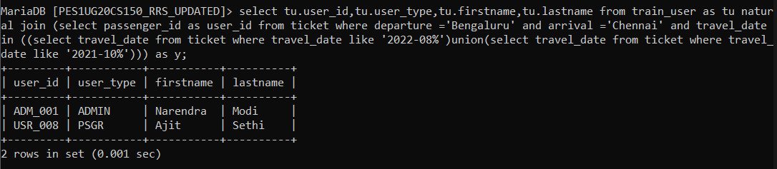

2. Find the list of passengers (user_id, user_type First name and

last name) who have traveled from Bengaluru to Chennai during

the month of Oct 2021 and also during Aug 2022.

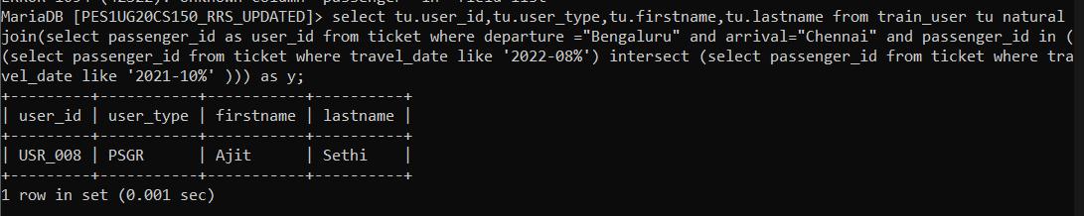

3. Find the list of passengers (user_id, user_type First name and

last name) who have traveled from Bengaluru to Chennai during

the month of Aug 2022 and not in Oct 2021.

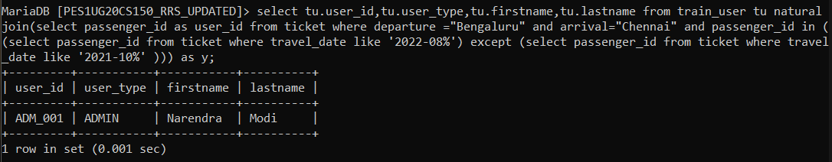

4. Find the list of passengers (user_id, user_type, First name and

last name) who have traveled from Bengaluru to Chennai and

returned to Bengaluru within a week.

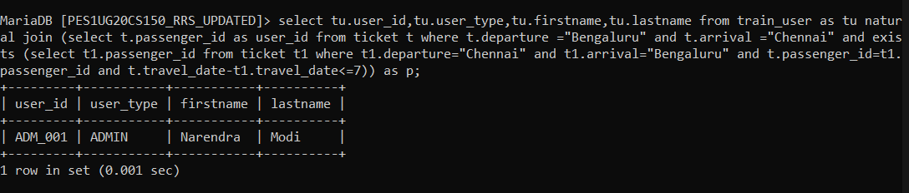

5. Find the list of passengers (user_id, user_type, First name and

last name) who have traveled from Bengaluru to Chennai and did

not return to Bengaluru (in other words, only one way travel

from Bengaluru to Chennai).

